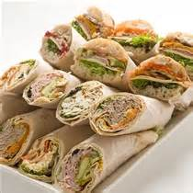
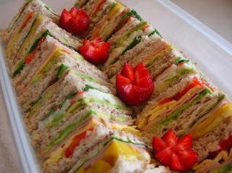
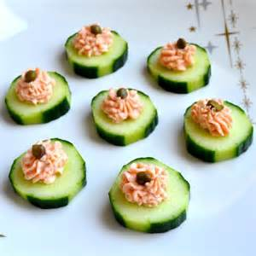
Corporate Catering Menu
*Guaranteed best Value *Corporate Accounts Available *Same Day Service
*Easy access and parking *Delivery available from $15.00 *Specific Dietary Needs meet

We Can Cater to Suit your needs!
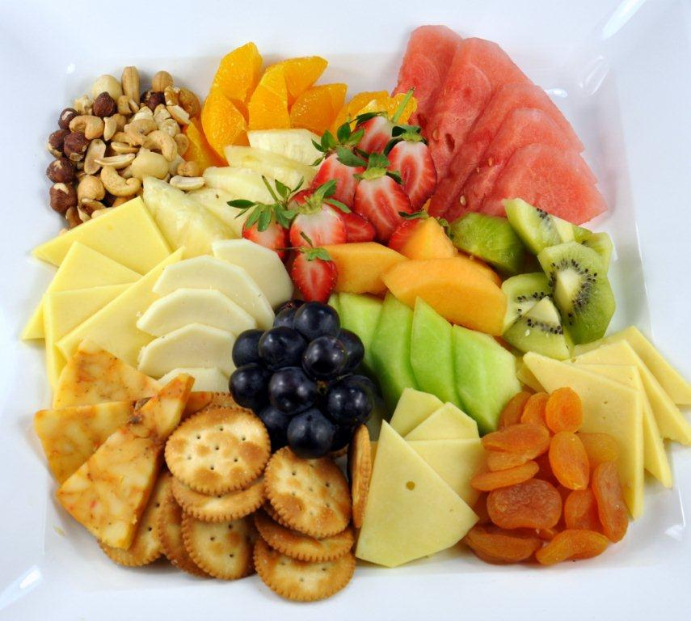
Please find overleaf our comprehensive catering menu. Large catering and specific needs may require 24 hours notice.
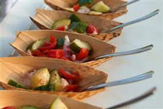
Fresh daily produce is used in all our catering and some items require minimum numbers.
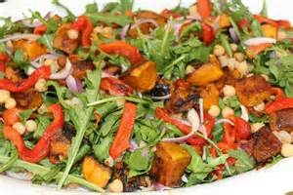
Breakfast
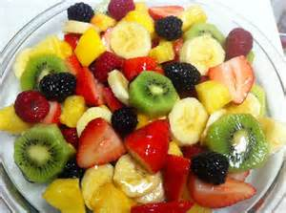
Option 1
Hot Breakfast
Cost $14.00
*Ham Cheese Croissant
*Egg and Bacon Muffins
* Warm Danishes
*Seasonal Fruit Salad
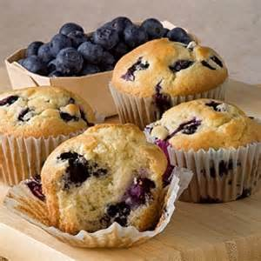
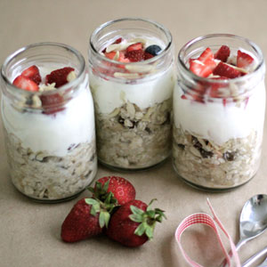
Option 2
Cold Breakfast
Cost $13.00
*Bircher Muesli individual serves
*Fruit muffin*Selection of Danishes
*Seasonal Fruit Salad
Morning & Afternoon teas
All Prices are per person
Option Mt 1 Option Mt 2
Sweet Platter $5.50 Seasonal Fruit Platter $6.50
*mini cakes *Fresh Daily Seasonal Fruit
*home made chocolates
*home made truffle balls

Option Mt 3 Option Mt 4 Option Mt 5
Devonshire Tea Platter $5.50 Cheese Platter $11.00 Sweet & Savory $10.50
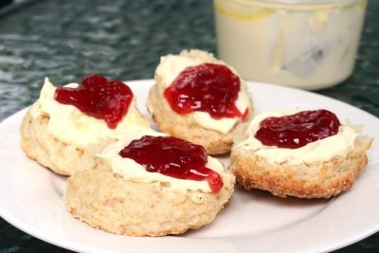
*Scones, jam and cream *Selection of fresh cheese *quiche or frittata wedges
*grapes *fresh & dried fruit *crackers *Variety of mixed sandwiches
*olives *Cabnossi Sausage *nuts *mixed cakes
*Seasonal Fresh Fruit

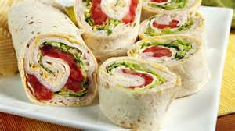
Lunch boxes
Option 1 Option 2
Breakfast box Something small box
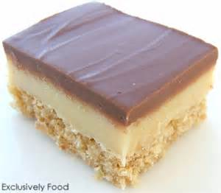
1 large fruit muffin 1 mixed sandwich
1 piece fruit 1 piece fruit
1 Bacon and Egg Roll 1 cake & 1 chocolate
1 juice box 1 juice box
$14.00 $14.00
Option 3 Option 4
Large Sandwich box Hot meal box
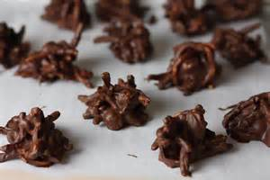
1 Sandwich or Tortilla & 1 piece fritatta 1 hot meal of the day & 1 Bread roll
2 piece fruit 1 piece fruit
1 Cake or goji ball & 1 chocolate 1 cake or goji & 1 chocolate
1 juice box 1 juice box
$16.00 $17.00

Option 5 Option 6
Gluten free/Vegetarian box Vegan meal box
1 large slice vegetarian, gluten free frittata w side salad 1 salad of the day & crudités with babaganoush
2 piece fruit & nuts, dried fruit 1 piece fruit & nuts, dried fruit
1 goji ball 1 goji ball
1 juice box or coconut water 1 juice box or coconut water
$16.00 $16.00
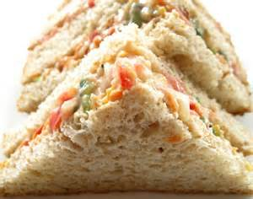
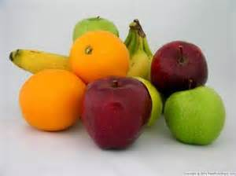
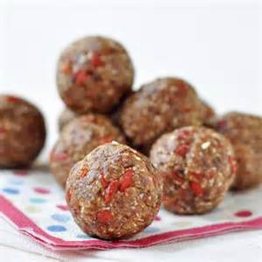

Cold Lunches
All Prices are per person
Option CL 1 Option CL 2 Option CL3
Mixed Sandwiches/wraps $9.50 Basic with a Twist $10.90 Mini Cold Buffet $13.00
*Mixture of white, wholemeal *Combination of gourmet *Petite wraps, includes vegetarian
Multigrain petite sandwiches and Sandwiches, wraps and option
Fillings, including vegetarian Turkish bread sandwiches *Vegetarian and Gluten free Frittata
options includes vegetarian options *Smoked salmon mousse on top
of cucumber rounds
*petite bruschetta
* Freshly baked quiche
*fruit, chocolate truffles and
Homemade chocolates
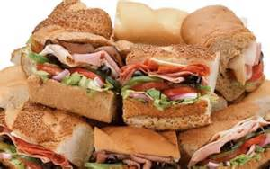

Hot Lunches
All Prices are per person
Option HL 1 Option HL 2 Option HL 3
Budget Hot Platter $10.90 Gourmet Finger food $20.00 Hot Banquet $27.00
*Mini Sausage rolls *mini vegetarian Kebabs v/gf *Selection of 3 homemade
*Mini Pies *Potato Nest filled w herb Dishes
*Cocktail Spring rolls mushrooms v/gf/vegan *Steamed rice
*Samousa *chicken & ricotta sausage roll *Fresh Garden Salad
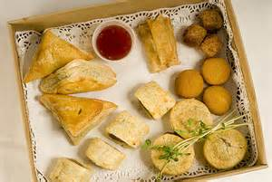
*Mini dim sims *smoked salmon mousse on *Garlic Bread
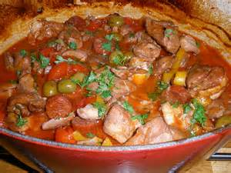
Herbed blini
*Thai fish cakes g/f
*Sweet Chilli chicken strips
*Sweet & fruit platter

Salads
All Prices are per tray SMALL $27.00 LARGE $40.00
Option S 1 Option S 2 Option S 3
Pumpkin Pinenut Salad Pesto Chicken Salad Greek Salad
*Roast Pumpkin *Grilled Chicken Breast *mesculin
*Mesculin *Mesculin *cherry tomatoes
*cucumber *Parmesan Cheese *Kalamata Olives
*fetta *Chopped Walnuts *Spanish Onion
*pine nuts *Avocado *Fetta Cheese
*Sundried tomato strips *tossed through basil pesto *Cucumber
*Cous cous
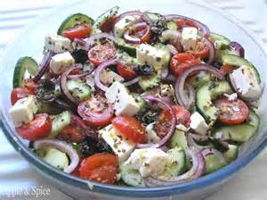
*Fresh herbs
*tossed through a light balsamic
And olive oil dressing

Salads
All Prices are per tray
Option S 4 Option S 5 Option S 6
Caesar Salad Pasta Salad Haloumi, watermelon, olive & mint
*Baby Cos *Penne Pasta *Spinach leaves
*Crisp bacon *chargrilled vegetables *Grilled Halloumi
*parmesan cheese *fetta cheeses *Kalamata olives
*coddled egg *shallots *Watermelon
*crunchy croutons *Fresh Basil *mint
*Caesar Dressing *tomato pesto dressing *lemon juice, flaxseed oil dressing
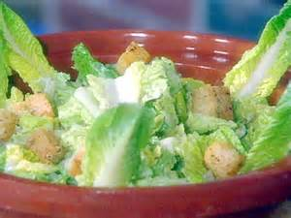
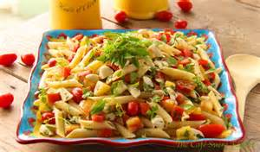
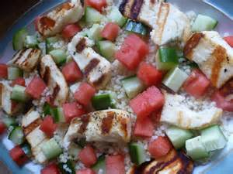

Cold Canapes
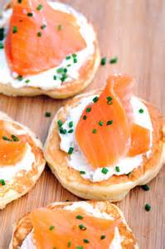
Cured Salmon mousse on herb blini
Baby roma tomato with buffalo mozzarella basil and balsamic gf/v
Caramelized onion, roma tomato on pumpernickel round with crème fresh and salmon
Baby roma tomatoes filled with bubagaosh and olive tapenade gf/vegan/v
Salmon mousse on cucumber rounds
Pancetta wrapped melon
Ceviche with lavosh wafers
Mini bruschetta of tomato, basil, Spanish onion with balsamic glaze
Miniature vegetarian frittata gf/v
Bamboo boats filled with haloumi, watermelon, fetta, pinenut salad with lemon and mint g/f
Crab, coriander, lime mousse on a corn blini g/f
Mini prawn cocktails on baby cos lettuce g/f

Minimum 10 persons 6 selections/$14 per person
8 selections/$18 per person
10 selections/$22 per person

Peking duck mini crepes with shallot, cucumber and hoisin sauce
Chorizo, blue cheese & caramelised onion mini tartlets
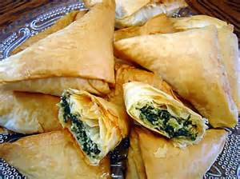
Hot Canapes
Crumbed chicken lollypops with Caesar dressing
Thai style fish cakes with cucumber dipping sauce gf
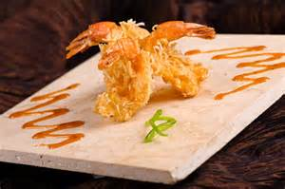
Salt and pepper squid with wasabi and lemon aioli
Mini vegetarian kebabs with peanut dipping sauce gf/v/vegan
Mini Greek spinach and feta filo pastries v
Coconut and macadamia prawns with curried aioli g/f
Chicken and ricotta sausage rolls
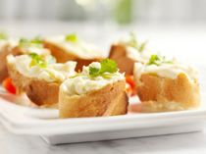
Potato nest filled with salmon mornay, lemon and dill g/f
Potato nest filled with herbed mushrooms v/vegan
Mini slides with Angus beef, caramelised onion, lettuce and tomato
Pork sausages in a petite bread roll with Dijon mustard
Vegetable and tofu skewers with peanut satay gf/v/vegan
Spanakopita – spinach and feta mini filo pastry v/vegan

Minimum 10 persons 6 Selections $15.00
8 Selections $20.00
10 Selections $24.00

Mini gourmet pies
Noodle boxes
Cold Hot
Thai Beef Salad gf Thai green chicken curry w rice gf
Thai chicken salad gf Indian Butter Chicken w rice
Chicken Caesar Salad Vegetarian Fried Rice v/vegan
Pumpkin Pinenut Salad v/vegan Lamb Rogan Josh w rice
Greek Salad v (add chicken ) Pesto chicken parmesan pasta
Penne pasta salad v lasagne
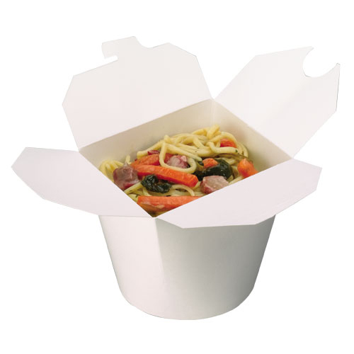
Minimum 10 persons $10.90
For specific orders/requirements minimum 24 hours needed
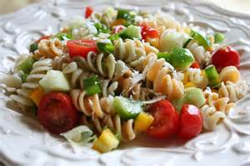
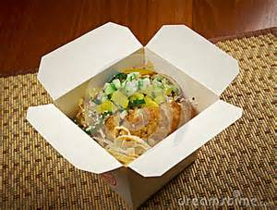
An assorted variety is available daily in smaller quantities from our display fridge

